SIMATS ENGINEERING
ASSESSMENT TOOL 1
Experiments
COURSE NAME: OBJECT ORIENTED ANALYSIS AND DESIGN
COURSE CODE: CSA11
COURSE OUTCOME COVERED
CO3: Analyze system requirements using object-oriented techniques to identify classes, attributes, and relationships and develop use case models. (BL4)
Assessment Tool Weightage: 40%
QUESTIONS:4 Total Marks:40

Code of Conduct / Declaration
I V Mahalakshmi [192421343]___ (Name / Reg No) certify that this submission is my original work and that I have adhered to the guidelines specified for this assessment. I understand that any violation of academic integrity rules will result in disciplinary action.

Signature of the student: ______________________________

1. Develop a system using UML for implementing the Book Bank process. It should verify the details of the student by the central computer. The details regarding the student will be provided to the central computer through the administrator in the book bank and the computer will verify the details of the student and provide approval to the office. Then the books that are needed by the student will issue from the office to him.

Problem Statement
The Book Bank system verifies student details through a central computer. The administrator enters the student's details, the central computer verifies them and sends approval to the office, and the office issues the required books.

1. Actors
- Student
- Administrator
- Central Computer • Office

2. Functional Requirements
- Submit Student Details
- Verify Student
- Provide Approval
- Request Books
- Issue Books
- Record Issue

3. Design Assumptions
- The Administrator enters or submits the student's details.
- The Central Verification System checks whether the student is eligible.
- The Office issues books only after successful verification.
- The Book Bank records the issued books.

4. UML Use Case Diagram

Figure: Use Case Diagram
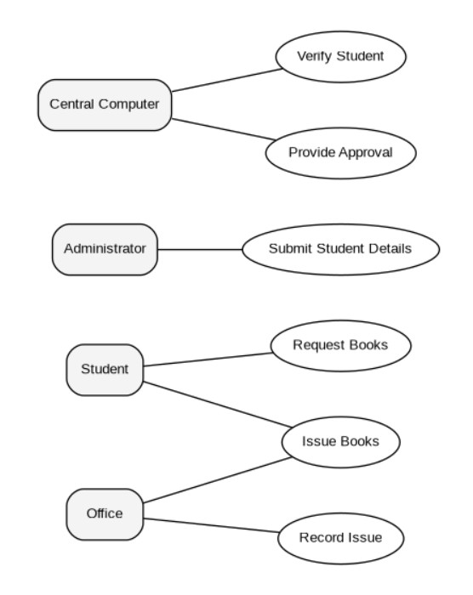

5. UML Activity Diagram

Figure: Activity Diagram
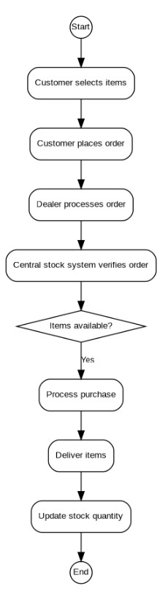

6. UML Class Diagram

Figure: Class Diagram
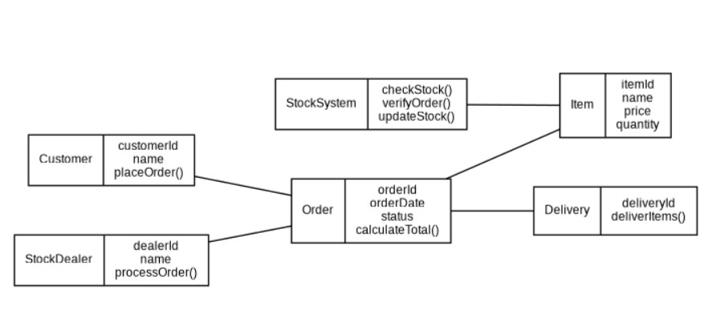

7. UML Sequence Diagram

Figure: Sequence of Major Operations
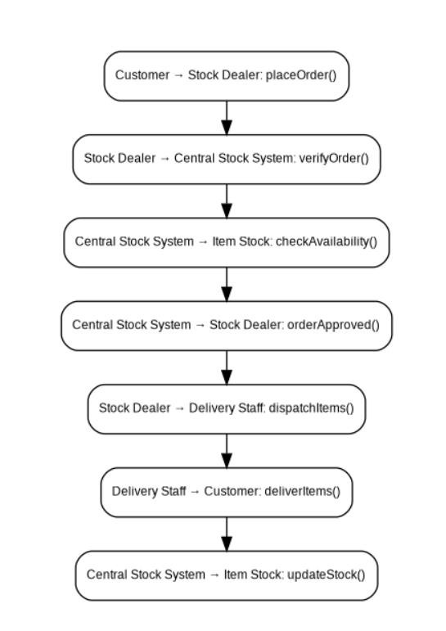

8. Explanation of the Design
The Administrator supplies student details to the Central Verification System. The system checks eligibility and sends approval to the Office. The Student then requests the required books. The Office checks book availability, issues the books and records the issue.

9. Result
The UML model for the Book Bank Management System was developed successfully. The model identifies the main actors, use cases, classes, relationships, activities and interactions required to implement the system.

2. Develop a system using UML for implementing the Exam Registration Portal. It should verify the details of the candidate by the central computer. The details regarding the candidate will be provided to the central computer through the administrator and the computer will verify the details of the candidate and provide approval. Then the hall ticket will be issued from the office to the candidate.

Problem Statement
The Exam Registration Portal verifies candidate details using a central computer. The administrator provides the candidate details, the system verifies them and provides approval, after which the office issues the hall ticket to the candidate.

1. Actors
- Candidate
- Administrator
- Central Computer
- Office

2. Functional Requirements
- Submit Candidate Details
- Verify Candidate
- Provide Approval
- Register for Exam
- Generate Hall Ticket • Issue Hall Ticket

3. Design Assumptions
- The Administrator submits candidate registration details.
- The Central Computer verifies candidate eligibility.
- A hall ticket is issued only after approval.
- The Office can access the approved candidate record.

4. UML Use Case Diagram

Figure: Use Case Diagram
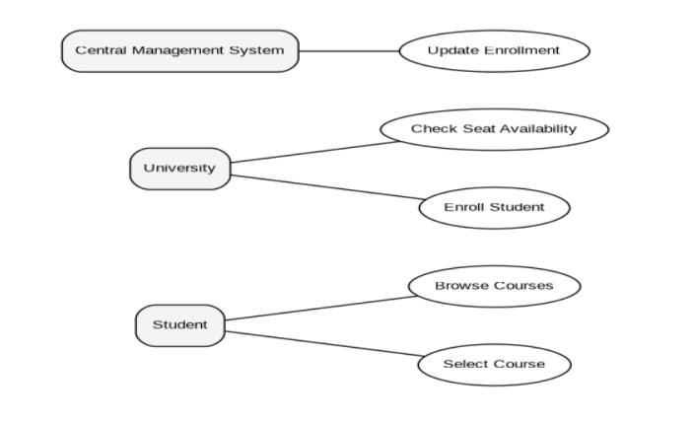

5. UML Activity Diagram

Figure: Activity Diagram
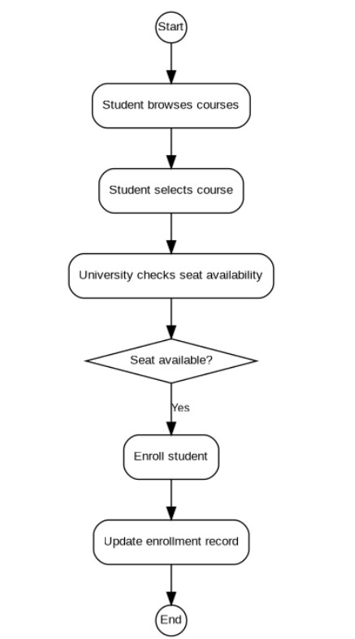

6. UML Class Diagram

Figure: Class Diagram
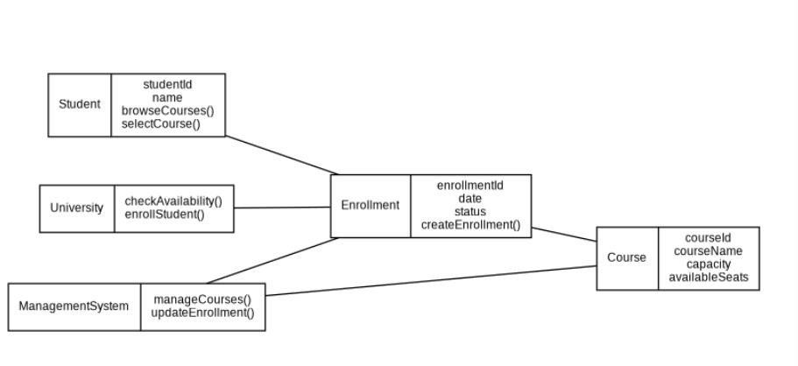

7. UML Sequence Diagram

Figure: Sequence of Major Operations
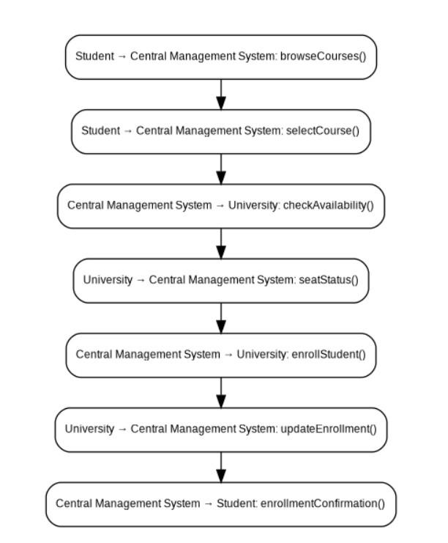

8. Explanation of the Design
The Administrator submits candidate information for verification. The Central Computer checks eligibility and provides approval. After approval, the Office generates and issues the hall ticket to the Candidate.

9. Result
The UML model for the Exam Registration Portal was developed successfully. The model identifies the main actors, use cases, classes, relationships, activities and interactions required to implement the system.

3. Develop a system using UML for implementing Stock Maintenance System. In this system, the customer can place orders and purchase items with the aid of the stock dealer and central stock system. These orders are verified and the items are delivered to the customer. Then the stock details are to be updated accordingly.

Problem Statement
The Stock Maintenance System allows a customer to place orders and purchase items with the help of the stock dealer and central stock system. Orders are verified, items are delivered, and stock details are updated after the purchase.

1. Actors
- Customer
- Stock Dealer
- Central Stock System • Delivery Staff

2. Functional Requirements
- Browse Items
- Place Order
- Verify Order
- Check Stock
- Process Purchase
- Deliver Items
- Update Stock

3. Design Assumptions
- The Customer selects items and places an order.
- The Stock Dealer assists with order processing.
- The Central Stock System verifies availability and the order.
- After delivery, stock quantity is updated.

4. UML Use Case Diagram

Figure: Use Case Diagram
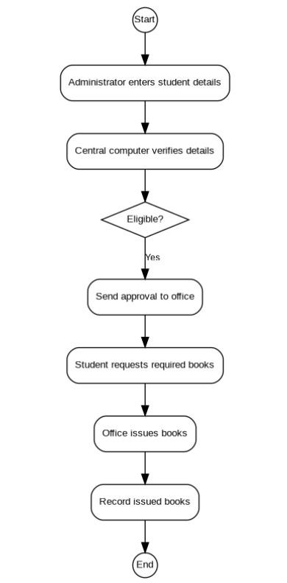

5. UML Activity Diagram

Figure: Activity Diagram
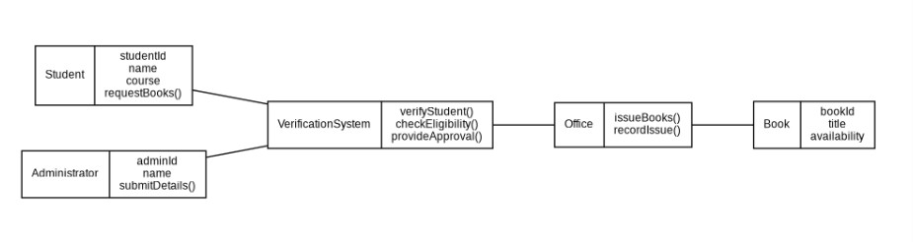

6. UML Class Diagram

Figure: Class Diagram
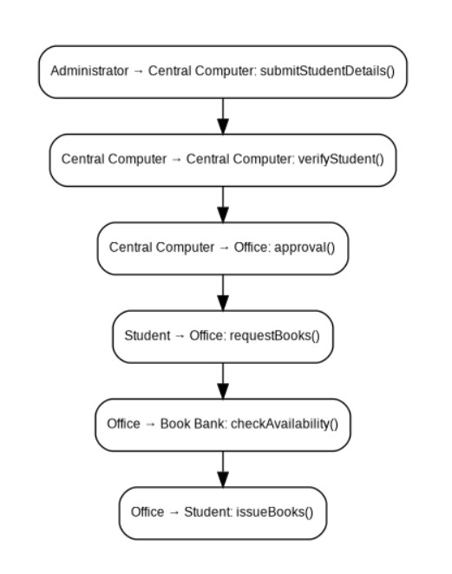

7. UML Sequence Diagram

Figure: Sequence of Major Operations
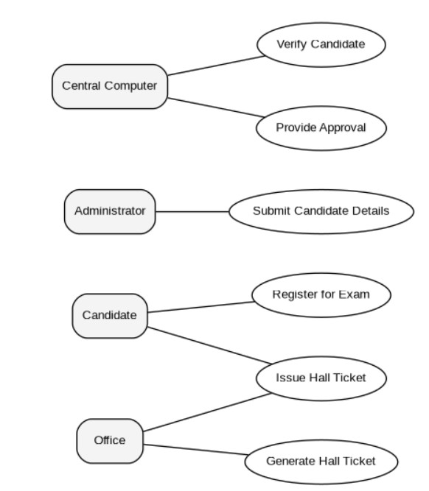

8. Explanation of the Design
The Customer places an order with the assistance of the Stock Dealer. The Central Stock System checks the order and item availability. After verification, the items are dispatched and delivered. The stock quantity is then updated to reflect the completed purchase.

9. Result
The UML model for the Stock Maintenance System was developed successfully. The model identifies the main actors, use cases, classes, relationships, activities and interactions required to implement the system.

4. Develop a system using UML for implementing Online Course Reservation System. This system is organized by the central management system. The student first browses and selects the desired course of their choice. The university then checks the availability of the seat if it is available the student is enrolled for the course.

Problem Statement
The Online Course Reservation System is organized by the central management system. A student browses and selects a course. The university checks seat availability, and if a seat is available, the student is enrolled in the course.

1. Actors
- Student
- University
- Central Management System

2. Functional Requirements
- Browse Courses
- Select Course
- Check Seat Availability
- Enroll Student • Update Enrollment

3. Design Assumptions
- The Student can browse and select available courses.
- The University checks the current seat availability.
- Enrollment is completed only when a seat is available.
- The Central Management System maintains course and enrollment information.

4. UML Use Case Diagram

Figure: Use Case Diagram
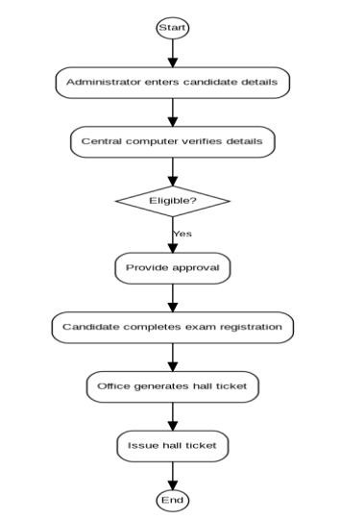

5. UML Activity Diagram

Figure: Activity Diagram
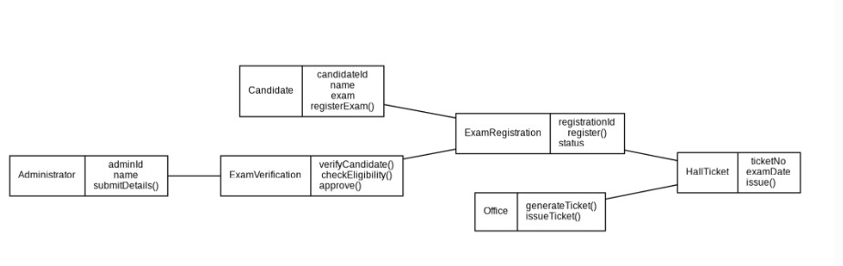

6. UML Class Diagram

Figure: Class Diagram
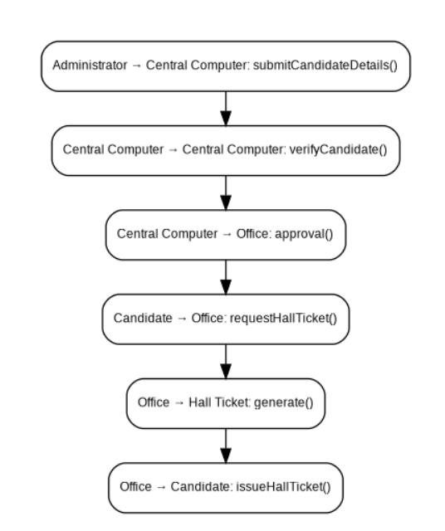

7. UML Sequence Diagram

Figure: Sequence of Major Operations
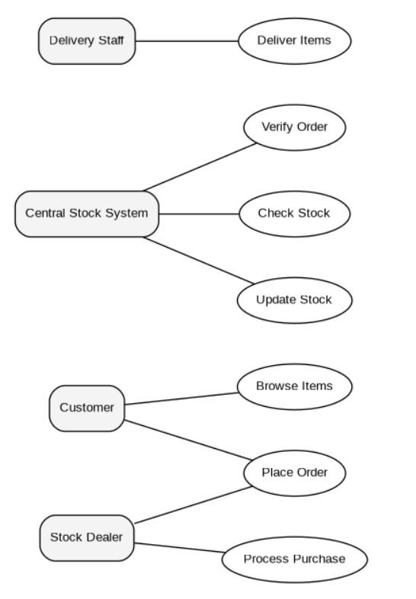

8. Explanation of the Design
The Student browses the available courses and selects a course. The University checks the number of available seats. If a seat is available, the student is enrolled and the Central Management System updates the enrollment record. If no seat is available, enrollment is not completed.

9. Result
The UML model for the Online Course Reservation System was developed successfully. The model identifies the main actors, use cases, classes, relationships, activities and interactions required to implement the system.

